Verge and Open Space Grassland Survey
Management Guidelines
Site Name:  Ballykelly Playing Fields | Reference Number:  Open Space CP9
Grid Reference:  C635 222 | Survey details:  Survey area: Area A (69.3m²)  Date first surveyed: 18.08.2016

Site description:
This small site comprises two small strips of amenity grassland at either side of the entrance to the playing fields. Area A is a narrow strip of grassland approximately 1.5 metres wide and 26 metres long at the western side of the entrance (see map). This had not been cut at the time of the survey and supported several species of grasses including soft brome Bromus hordaceus. Common ragwort Senecio jacobaea was also frequent.
Area B had been very recently mowed and was not surveyed. However this area should also be managed, making the combined extent of the grassland under management over 200m².
Management Options:
- Mow twice each year – early spring and again in late season (September). If two cuts are not possible, one late cut is recommended.
- Remove all cuttings. As the area is small these could potentially be raked and removed by volunteers.
- Litter may be an issue here and should be lifted prior to cutting
- Survey in June or July – whole area
- Review management options every 3 years

Open space CP9
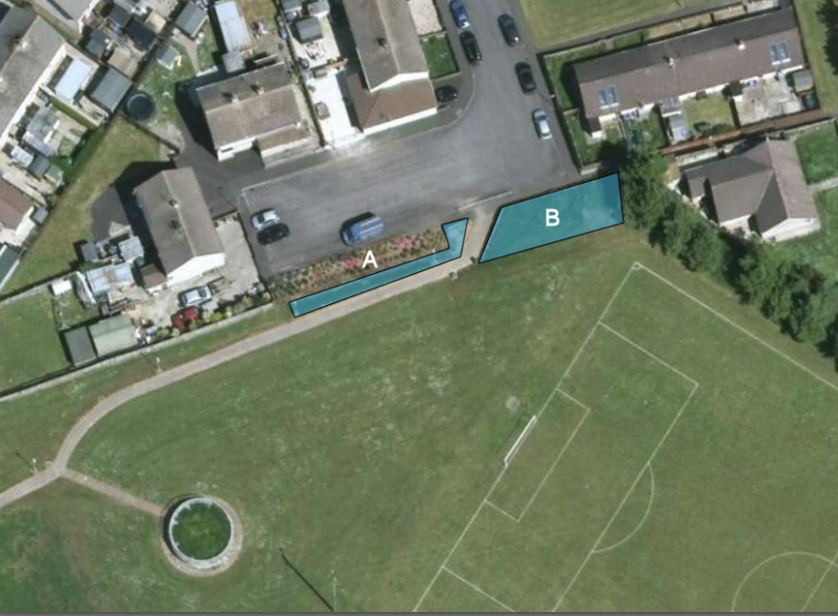
Area A 18th August 2016
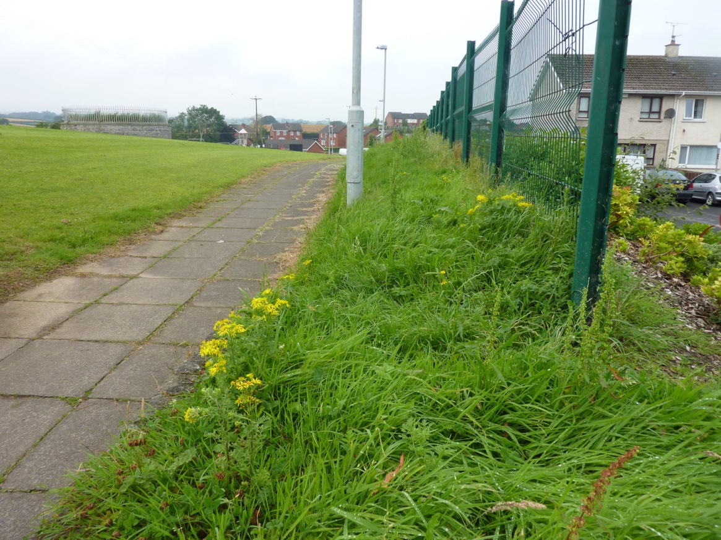
Area B 18th August 2016
