Verge and Open Space Grassland Survey
Management Guidelines
Site Name:  Belraugh Rd (B190) / Coolnasillagh Rd junction (S) to B70 Boleran Rd junction (N) | Reference Number:  Verge 11 (both sides)
Grid References:  C779 176 (S) to C800 212 (N) | Survey details:  Four quadrats  C78344 18133 (West Side)  C78672 18579 (West Side)  C80063 21084 (East Side)  C77992 17649 (West Side)  Date first surveyed: 24/05/2016

Site description:
This is a variable pair of verges with more diversity on the western verge. The more northerly stretches are less diverse, more damaged and adjacent to improved fields. Historic cutting has left the inner parts of the western verge densely thatched and is now becoming invaded by willows, gorse, dog rose and brambles. Where soils are thinner the possibilities are revealed by patches of lady’s smock, lady’s mantle, wood anemone, bush vetch and meadow vetchling. The southern verge partly borders Coolnasillagh ASSI which supports a typical acid grassland flora and associated Lepidoptera, hoverflies and bees. A single wood tiger was observed on the verge in this area as well as orange-tips and green-veined whites. The northerly stretches are generally poor with soft rush density increasing as well as far more creeping buttercup and thistles. This part is also rutted badly in some areas and there was some fly-tipping. The verge has great potential if managed sensitively.
Management Options:
- Mowing: The whole area should be mown and the material removed in August/September of each year. An early spring cut may also be advisable as long as the cuttings are removed.
- Remove litter. A litter pick should be organised by local volunteers prior to mowing. Report any further fly-tipping.
- Survey: If possible do an initial survey in May/June (if early cut is applied) and repeat in July/early August.
- Review management options every 3 years
Site Map
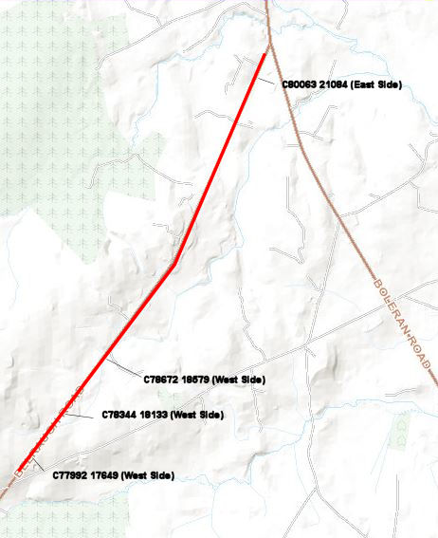

Images
Southern point, west side, looking north
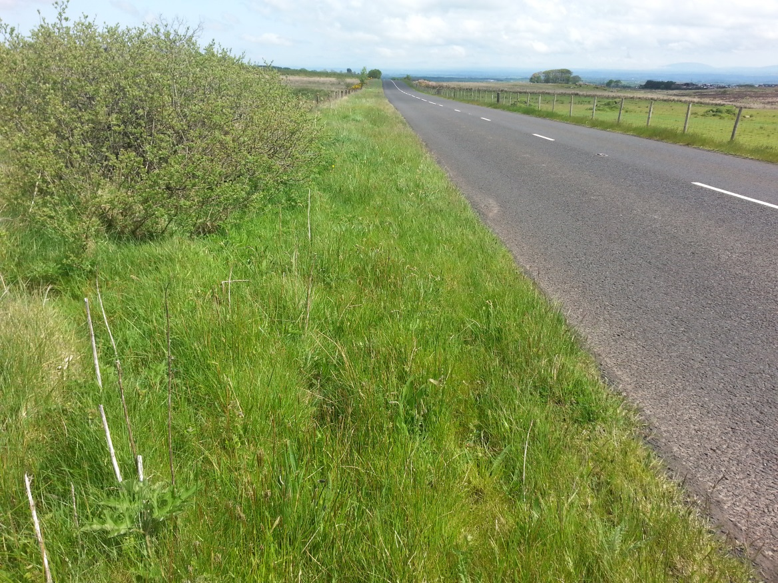
Mid-point, west side, looking north
