Don’t Mow, Let it Grow
Economic Appraisal of Grassland Management

Final Report
Causeway Coast and Glens Borough Council
December 2019

This document has been prepared for the Causeway Coast and Glens Borough Council by:

Economics for the Environment Consultancy Ltd (eftec)
3rd Floor
4 City Road
London
EC1Y 2AA
www.eftec.co.uk

Study team:
Ian Dickie
Erin Gianferrara
Francesco Cherchi

Reviewer
Ian Dickie

Acknowledgements
With thanks to the Heritage Lottery Fund and Landfill Communities Fund for their contributions towards financing the project, and project partners for their help supplying and interpreting data.

Disclaimer
Whilst eftec has endeavoured to provide accurate and reliable information, eftec is reliant on the accuracy of underlying data provided and those readily available in the public domain. eftec will not be responsible for any loss or damage caused by relying on the content contained in this report.

Document evolution

Draft Report | 20/12/2018 | Reviewed by Ian Dickie
Final Report | 26/04/2019 | Reviewed by Rachel Bain

Summary
This report provides an economic assessment of the impacts from the Don’t Mow, Let It Grow project. The benefits of the project have been assessed from a variety of perspectives:

- The ground flora of 36 project sites was surveyed over three years, showing an improvement of the ratio of flowering plants to grasses - there is a clear trend of a decrease in sites with a higher proportion of grasses, and an increase in sites with a 50:50 ratio or higher proportion of flowering plants.
- Public perception survey results show a range of positive attitudes to the project’s work:
  - 98% of respondents felt it is important to manage areas for wildlife.
  - 83% preferred long grass.
  - 96% felt it is important to increase public understanding of native plants and wildlife.
  - 81% felt the quality of greenspace influenced decision to visit an area.
- Wildlife benefits were rated as the most important benefits of the project, followed by well-being, and monetary savings benefits respectively. The finding that 81% of all respondents agreed or strongly agreed that “The quality of greenspace impacts their decision of whether or not (or how often) to visit the area.” Is significant. Roughly half of those surveyed were not resident in the project area, so this has implications for economic impacts that arise from visitors and tourism. It provides clear evidence linking the positive management of greenspaces for wildlife to visitor numbers and associated visitor spending.
- The project benefits from inputs from over 40 volunteers and in-kind staff contributions. These inputs are values at approximately £155,000 over the three years of the project. This is more than double the project’s original target. The project also ran 26 training events, with 320 participants receiving over 660 hours of training. This training is conservatively valued at £100,000.
- The project detected of invasive alien species at other Council and DfI roads sites. This enabled measures to avoid spread of these species, resulting in savings of subsequent control costs. This benefit is estimated at £19,440 during the lifetime of the project, and substantially more in the longer term.
- An estimate can be made of the monetary value of the project benefits. Through value transfer from a study valuing grassland enhancement in England and Wales (Rayment and Christie, 2012), the benefits are estimated at £2,800 per year in 2018. Given the relatively low value of this figure, and the uncertainty of this value transfer approach, the conclusions above are considered a better indication of project results.
- The change in mowing regime from at least fortnightly summer mowing to once a year results in significant cost savings. Assuming raking and removing cuttings can be cost neutral (e.g. cuttings can be sold), savings of over 90% (equivalent to £63,000 per year for the project area) can be achieved, providing resources to re-invest in maintaining or enhancing other environmental features.
- These costs savings can potentially be achieved on substantial areas of the public estate that are currently managed as mown grassland, for example in other roads departments, at hospitals and social housing providers. For the Causeway Coast and Glens Council, there are between 89 and 143 ha of grassland which are currently cut frequently and could instead be subject to the Don’t Mow Let It Grow management approach. Further potential cost savings on this land are estimated at between £494,000 and £798,000 per year.

Contents
1. Introduction 6
1.1 Biodiversity & Biodiversity Loss in Northern Ireland 6
1.2 Causeway Coast and Glens Borough Council 6
1.3 Don’t Mow, Let it Grow Objectives 7
2. Methodology 8
3. Results 10
3.1 Changes to Sites Managed 10
3.2 Public Perception Survey 11
3.3 Costs of Grassland Management 12
3.4 Estimate of Monetary Value of Project Benefits 14
3.5 Conclusions 16
Annex 1 – Public Perception survey 17

Introduction
This section outlines some background on the biodiversity and biodiversity loss in Northern Ireland, forming the context for the Don’t Mow, Let it Grow Project in the Causeway Coast and Glens, and the aims and objectives of this report.

Biodiversity & Biodiversity Loss in Northern Ireland
For its size, Northern Ireland is one of the most geologically diverse areas on the planet, and as a result Northern Ireland’s biodiversity is internationally important. Estimates suggest at least 23,500 different species across all taxa can be found across the nation’s wealth of habitats, including some species such as the cryptic wood white butterfly which is not found elsewhere in the UK.

However, this biodiversity is under threat. Much like the global challenge which is seeing species being lost up to 1,000 times faster than the natural rate as a result of human activities, estimates suggest the UK has lost over 100 species during the last century with many more under threat of extinction. Over 1,400 species known to occur in Northern Ireland have been assessed using the IUCN Red List criteria, and of these 20% were found to be at risk of extinction from the island of Ireland². The majority of the Island of Ireland’s habitats listed under the Habitats Directive are reported to be of poor or bad conservation status, with only 7% being listed as having favourable status, and only 39% of species listed are in a favourable state³. Five key factors have been identified as driving biodiversity loss; habitat change, overexploitation, pollution, climate change, and invasive alien species

Causeway Coast and Glens Borough Council
The Causeway Coast and Glens Borough Council, shown in Figure 1.1, was established in 2015 from the legacy councils of Ballymoney, Coleraine, Limavady and Moyle, covers an area of almost 2,000 km² and has a population of over 140,000, with 52% living in rural areas. The council area has a diverse range of habitat types, including woodland, grassland, bog, heathland, peatland, wetland, coastal and marine habitats. There are almost 120 designated sites within the council area, including one World Heritage Site, 58 Areas of Special Scientific Interest (ASSI), 12 Special Areas of Conservation (SAC), 4 Special Protection Areas (SPA), 3 Ramsar sites, 13 Nature Reserves, and 209 Sites of Local Nature Conservation Importance (SLNCI). Of the 51 NI Priority Habitats, at least 39 occur within the area⁴.

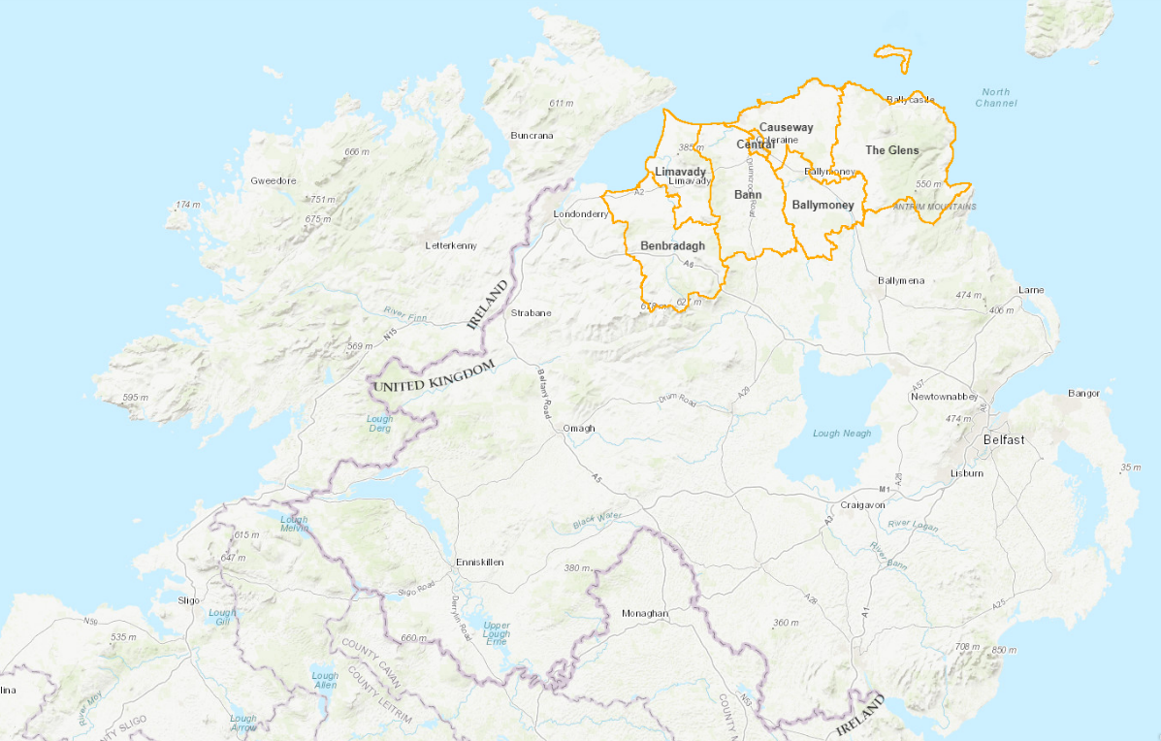
Figure 1.1: The Causeway Coast and Glens Borough Council (orange) within Northern Ireland
(Source: https://www.causewaycoastandglens.gov.uk/maps/)

Don’t Mow, Let it Grow Objectives
Led by the Causeway Coast and Glens Borough Council, Transport Northern Ireland (now DfI Roads) and Northern Ireland Environment Agency, Don’t Mow, Let it Grow is a pilot project designed to address some of the issues of biodiversity loss in Northern Ireland by enhancing the management and conservation of semi-natural grassland. The overall objectives of Don’t Mow, Let it Grow Project are to improve grassland biodiversity through education and alternative management approaches in the Causeway Coast and Glens. This report provides an economic analysis to support the project, covering analysis of:

- Data from the project’s public perceptions survey.
- The costs of different grassland management approaches.
- Evaluation of the benefits of the grassland management undertaken.

The analysis and results described in this report relate to project aim for the economic appraisal of the costs and benefits of different management options to restore semi-natural grasslands within the Borough, and the extrapolation of this more widely across Northern Ireland.

Methodology
The results from the project relate to the management of 36 roadside verges and Council park grasslands across the Causeway Coast and Glens Borough, shown in Figure 2.1. These trial sites have been managed in the traditional meadow way, which is to cut once a year and remove the cuttings where possible, with one site, Magilligan Point, being managed through low intensity winter grazing.
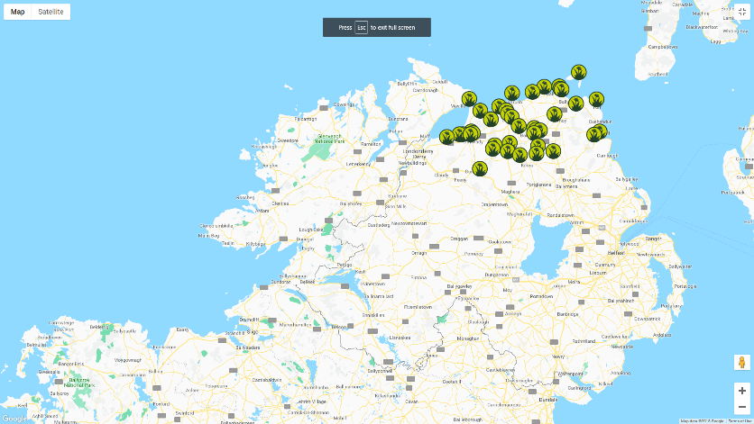

Figure 2.1: Location of the 36 roadside verges and Council parks within the Causeway Coast and Glens Borough Council
(Source: https://dontmowletitgrow.com/verges-open-space-grasslands/)

Three types of analysis have been undertaken for the project:
- Public Perception Survey
Public perception is crucial to the success of projects such as Don’t Mow, Let it Grow, which relate to the use of public resources and land. The altered grassland management can challenge people’s ‘sense of place,’ their attachment to a neighbourhoods’ current condition, with social norms being a key factor influencing residents preferences. For this reason, a public perception survey was undertaken, the survey questions are shown in Annex 1. The survey was conducted over three years, and asked questions relating to participants perceived importance of wildlife, well-being and money-saving benefits, and crucially their preference for long or short grass on roadside verges and in Council parks. The survey was analysed, based on annual and cumulative results, using simple descriptive statistics and percentages.
- Costs analysis
Data on the areas of grasslands managed through the project and the unit costs of that management were assessed. These were used to estimate the overall cost implications of the management approaches, both in terms of savings realised, and potential savings if the Don’t Mow Let It Grow management approach was extended to other areas.
- Monetary Valuation of benefits
The monetary valuation of project outcomes was undertaken to help evaluated the costs and benefits of the project. The monetary value of benefits are estimated in two ways, firstly through the value of time inputted to the project, and secondly through use on non-market valuation evidence.

Results

Changes to Sites Managed
Data were analysed from surveys of species growing at 29 project sites, and show an improvement of the ratio of flowering plants to grasses during the project. This data was collected by a range of professional and volunteer surveyors, and data was not collected from all sites in all years. These factors result in some uncertainty when interpreting the data. However, there is a clear trend of a decrease in sites with a higher proportion of grasses, and an increase in sites with a 50:50 ratio or higher proportion of flowering plants, as shown in Table 3.1. This pattern of benefits was also borne out by expert assessment of individual sites with different pre-project management histories (Joey Dunlop which had been amenity grassland, and Rasharkin cemetery which been largely abandoned with no cutting for around three years). At both sites an increase in herbaceous species and orchid abundance was recorded.

Table 3.1: Change in Sward Mix 2016 - 2018
year | 100% grass | 25 flower/ 75 grass | 50 flowers/ 50 grass | 75 flower / 25 grass | 100% flower
2016 | 1% | 57% | 37% | 5% | 0%
2017 | 0% | 47% | 35% | 17% | 1%
2018 | 7% | 32% | 42% | 20% | 0%

A range of other species were also recorded during the surveys, including 15 different butterfly species, other insects, and three vertebrate species: common lizard, pygmy shrew and smooth newt. Two of the butterfly species are associated with grassland habitats, and they both increased significantly (ringlet: 18 sites in 2016, 25 sites in 2018; meadow brown 2 to 18 sites). A significant increase in bumblebee species (2 to 16 sites) is also noteworthy, illustrating the link to valuable ecosystem services such pollination. Pollination is vital for many of the nation’s diversity of wild plant species and production of many fruit and vegetables.

Another indicator of grassland species diversity is the presence of orchids. Increased numbers of orchids were reported anecdotally from several project sites. However, orchid numbers were not surveyed at enough sites to support an overall conclusion of the impact of the project’s activities.

These positive changes in the species present at the sites are all due to the change in management put in place, and involve naturally occurring plants and other species. No sites were seeded or subject to any other atypical management.

Public Perception Survey
The purpose of the public perception survey was to understand public opinion on managing grassland areas for nature. The results build a picture of how the project’s impacts are viewed by the wider public. It also gave a chance for the public to contribute their thoughts and opinions which helped develop the project, and can inform further use of the grassland management measures applied.

Across the 3 years (2016 - 2018) of the project, 1,043 people participated in the survey.

Key information gathered from the Public Perception Survey (collated for the three years 2016 – 2018), which was carried out to provide evidence to support the benefits of Don’t Mow Let it Grow, includes:

- Around 98% of respondents thought it is important to manage areas in NI for wildlife, with consistently positive results agreeing the importance of providing areas where wildlife can grow and seed (97%), where wild flowers can provide food for wildlife (99%) and helping to save endangered pollinators (99%).
- At the start of the survey 83% of respondents prefer the longer grass shown in photos to shortly mown grass (and 8% had no preference). At the end of the survey this had risen to 89% preferring longer grass (4% no preference).
- The vast majority of respondents (96%) felt it was important to increase public understanding of our native plants and animals.
- Wildlife benefits were rated as important by the largest percentage of respondents, closely followed by well-being benefits, and monetary savings benefits. Each of these were considered important by more than 90% of respondents.
- A small majority of respondents (59%) did not live in the CCG. Of those who were not residents, 41% are regular visitors to the area.
- 81% agreed or strongly agreed that “The quality of greenspace impacts their decision of whether or not (or how often) to visit the area.” This has particular implications for economic impacts that arise from visitors and tourism as it is strong evidence linking how the management of greenspace can increase visitor numbers and associated visitor spending.
- 52% of respondents are not happy with the current amount and quality of greenspace in their local area.
- Over 95% of respondents agree or strongly agree that:
  - Greenspace should be managed to benefit both humans and other species
  - Increasing the quality of local greenspace makes an area a more desirable place to live

The survey also provided information which can inform the project’s conclusions and approaches to continue the grassland management practices used by the project:

- Overall, while the vast majority (~80%) of respondents feel the attractiveness of flowers and managed verges are important, responses were more positive in terms of what benefits are delivered (e.g. it seems that although important, aesthetics are not as important to respondents as, say, increasing public understanding of native plants and animals). This is encouraging as it highlights that people are in support of DMLIGs aims to deliver multiple benefits, and is contrary to the arguments against long grass due to its ‘unattractiveness’.
- In terms of public awareness, people know the least about Japanese knotweed which is an invasive species, about the benefits/ rationale behind giving cut grass to farmers, and about why reducing the number of cuts is beneficial - so these are important things to communicate to the public.
- Around 10% of respondents don’t feel training to local volunteers and training kits are important, however this can be interpreted as lack of understanding (a similar proportion ‘don’t know’ whether these are important or not) of what the training provides – it ensures the continuation of benefits delivered by the verges and Council parks over time. This is therefore an important aspect to communicate throughout the project.
- People may not know that good quality green space (quality increases with increased biodiversity) in an area can increase property values so this could be a key point to share with people in terms of communicating our results.
- A slight majority of respondents (59%) did not live in CCG, however there were improvements each year in the proportion of residents that responded to the survey, indicating improving communication with the local community.
A site quality survey of verge and open spaces, spread evenly over the three years of the project, showed a 10% increase in grassland verge rated as ‘very good’ between 2016 and 2018 (14% to 24%). This was mirrored by a 9% increase in public survey respondents describing local grassland management as ‘historically mown’ during the same period.

Costs of Grassland Management
A key impact of the change in grassland management approaches used during the project is on costs. The sites covered by the project are managed by a Council and DfI Roads. In Northern Ireland Council parks and urban verges are typically mown every 10-14 days from April to September – approximately 15 times per year. With the non-urban road verges being cut anything from 1 – 3 times per year. The project changed this approach to a management regime where project sites were mown once per year.’

This change in management results in cost savings. The size of these savings has been calculated based on the Council park areas managed and an estimated average cost of mowing of 5 pence per square meter. The total size of sites managed under the project for which areas were recorded was 11.8 ha. Most of these were small sites, with only four sites having an area of more than 1 ha (10,000 sq. meters). Table 3.2 shows the estimated total costs of previous management, the new management approach and the cost savings.

Table 3.2: Estimated Management Cost Savings
Area - ha | Area – sq. m | Annual costs, £
 |  | Previous management | Don’t Mow management | Savings
11.79 ha | 117,900 | £68,455 | £5,351 | £63,104

The data in 3.2 illustrates substantial savings from the management approach adopted. Although the sums involved are not large in the context of Government budgets, they show significant savings (of over 90% of costs).

There are some uncertainties in the calculations in Table 3.2. These relate to using a simple average cost per sq. meter, and the management of grass cuttings. The budget savings that are possible are likely to vary with the size and proximity of sites (which will affect transport and other costs). To maximise benefits for grassland habitats, cuttings need to be raked and removed. In line with the experiences in the project, it is assumed this activity is cost neutral, as this material can be sold (e.g. as fodder or fuel), or at other sites was raked and removed by volunteers. However, if the management of cutting did incur a cost, this would not be expected to significantly effect the size of the cost savings that can be achieved.

The project’s work, and therefore the savings identified, are designed to be able to be replicated on other managed grassland areas. The figures identified (costs of 5p per sq. meter mown and cost savings of 90%) provide a useful way to provide a first estimate of the savings that the Don’t Mow Let It Grow management approach can offer. For the Causeway Coast and Glens Council, there are between 89 and 143 ha of grassland which are currently cut frequently and could instead be subject to the Don’t Mow Let It Grow management approach. If the same savings were made on this land, this would provide a further saving of between £494,000 and £798,000 per year. Discounted over 10 years this represents a saving of between £4.6 million and £7.4 million.

The savings made through the project, and that could potentially be made on other areas, can be usefully reallocated to positive environmental management actions by the bodies involved. The priorities for this spend can be determined locally, but on public land can include other biodiversity-friendly actions (e.g. measures for designated sites), providing adequate access to natural green space, and other nature-based solutions (e.g. Natural Sustainable Urban Drainage features).

Invasive alien species
Another aspect of grassland/ habitat management is the risk from invasive alien species. There are many non-native plant species in Northern Ireland which don’t cause problems. A few, however, can become invasive and upset the balance of ecosystems, affect property prices or present health and safety risks. They are often bigger, faster-growing or more aggressive than native species and may take over the habitat where they grow. For some species, this can create adverse impacts such that they have to be contained and/or removed, often at considerable expense. The overall costs of non-native invasive species in Great Britain was estimated at £1.7bn in 2010 (Williams et al). A significant proportion of these costs relate to invasive plant species, including £166m for Japanese Knotweed alone, and include costs for the agriculture and horticulture, and infrastructure sectors.

The Don’t Mow Let It Grow management approach means that invasive species are more likely to be detected as they can go undetected in closely mown habitats. When undetected they can be cut unintentionally and spread. However, their detection relies on site inspections by individuals with the appropriate skills. Site surveys by the project found Japanese Knotweed at two sites in 2016. Other invasive alien species that were checked for during site surveys were Giant hogweed (which was not detected in the survey areas but was found close to some sites) and Himalayan balsam (found at 3 sites).

In addition to detection at the survey sites, the project identified the presence of invasive alien species on 26 Council sites and over 119 Department of Infrastructure roads sites. This detection enables low-cost measures to be taken to avoid spread of the invasive alien species through cutting. These measures are estimated to reduce the risk of spreading the invasive alien species by at least 50% (and possible as much as 90% in some circumstances).

During 2017 and 2018 Council controlled Japanese knotweed and / or giant hogweed at 5 and 7 sites respectively. Control costs at these twelve sites had an average of approximately £270 per site. It is conservative to assume that the invasive alien species at each site would have been spread to at least one other site during the lifetime of the project (i.e. a further 145 sites). Avoiding spread from half of these sites (approximately 72 sites) saves on subsequent control costs, which are assumed to be £270 per site. The project’s early detection of invasive alien species therefore is estimated to have saved £19,440 (£270 per site at 72 sites). In the long term, the savings would be expected to be much higher than this.

Application of Cost Savings Results
The project conclusions that the Don’t Mow Let It Grow management approach can produce significant savings are relevant for grassland management by the public, private and third sectors across Northern Ireland, the rest of the United Kingdom, and the Republic of Ireland. For example, in the public sector roads maintenance sections, local Councils, many hospitals, social housing providers including NI Housing Executive, and other sites in the public estate have extensive areas of managed grassland.

Estimate of Monetary Value of Project Benefits
This section estimates a monetary value on the benefits from the Don’t Mow Let It Grow grassland management approach. Benefits are estimated in two ways, firstly through the value of time inputted to the project, and secondly through use on non-market valuation evidence.

Value of Volunteer Time
The value of time inputted to the project is an under-estimate of the value organisations expected to gain from it. Volunteering time is also an indicator of community engagement and capacity building.

The project benefitted from time inputted in time to undertake survey work and other activities. The project engaged 40+ volunteers, and also benefitted from in-kind contributions of staff time from several organisations. The time inputted also grew during the project, with approximately 155 days in 2016 and 2017, but 250 days in 2018. Thus in the final year of the project time inputs increased by a factor of 1.6. In 2018 the volunteering effort was spread over a larger number of volunteers, which is evidence of a growing network of engaged volunteers, and increased future volunteering capacity.

The value of volunteer inputs can be estimated based on the skill levels of the volunteers/ volunteering activity, and a typically daily cost of employing that skill level (source). Using this data and assumptions, the value of volunteering is estimated at approximately £45,000 in 2016 and 2017, and £68,000 in 2018. The increase in value in 2018 is due to both more volunteer days work, and more higher-skilled volunteering tasks.

In total the project benefited from approximately £158,000 of in-kind and volunteering time during its three years. The project’s target was to receive just under £60,000 of in kind and volunteering support, so the actual inputs received are more than double this target.

Value of Training
The project ran 26 training events delivering over 660 hours of training to over 320 participants. The value of training is estimated based on the opportunity cost of participants’ time. This is likely to be a significant underestimate of the knowledge gained and applied in subsequent activities. Using the same typical daily cost as the used to value skilled volunteer time (£150/day), gives a conservative estimate of the value of training of £100,000.

Non-market Valuation Evidence
The project did not have resources to undertake primary research to identify monetary values for the project impacts, so used the value transfer approach (eftec, 2010). Value transfer is the process of selecting relevant existing value evidence from the literature, adjusting it where necessary and applying it to the changes being evaluated.

Value transfer must take into account the types of impacts being valued and the context in which they occur. A full checklist of the factors to consider in value transfer is provided in UK guidelines (eftec, 2010). Value transfer brings a source of uncertainty, since it is dependent of obtaining suitable evidence. However, it provides a cost-effective way to value environmental impacts in monetary terms.

The most suitable valuation evidence available is from a study of benefits of SSSI conservation in England and Wales. This study produced valuations for the benefits to the general public of improving the condition of various habitats, including grassland. However, several adjustments were made to the figures to give the best possible valuation of the impacts of the Don’t Mow Let It Grow grassland management approach:

- The grassland habitats analysed in Christie and Rayment (2012) are based on the habitat typology in England and Wales and does not match the typology used in Northern Ireland. As a result an average of the values from four different relevant grassland habitats was taken from the Christie and Rayment data.
- Values were inflated to 2018 values using HM Treasury GDP deflators (unit values).
- The improvement values in Christie and Rayment (2012) relate to improvements in management that achieve favourable condition of grassland SSSIs. The size and other characteristics of the sites covered by the project mean that, although they are improved under the Don’t Mow Let It Grow grassland management approach, that improvement may not be sufficient to achieve an equivalent of SSSI favourable condition. Therefore, the lower values from the high-central-low range provided by Christie and Rayment (2012) are used.
Using these assumptions, we obtain an estimated value of £238/ha for the benefits of the improved management of the grassland sites under the project, in 2018 prices. For the area of the sites covered (11.79 ha - see Table 3.2), this gives an estimated annual benefit of approximately £2,800. This benefit has significant uncertainty, due to the assumptions described above, and also the transfer of values from a 2012 England and Wales study to the current context in Northern Ireland.

Conclusions
The benefits of the project have been assessed from a variety of perspectives in this report:

- The species growing at 29 project sites were surveyed in more than one year. These results, show an improvement of the ratio of flowering plants to grasses - there is a clear trend of a decrease in sites with a higher proportion of grasses, and an increase in sites with a 50:50 ratio or higher proportion of flowering plants.
- Public perception survey results show a range of positive attitudes to the project’s work – for example, wildlife benefits were rated as the most important benefits of the project, followed by well-being, and monetary savings benefits respectively.
- Furthermore, 81% of all respondents agreed or strongly agreed that “The quality of greenspace impacts their decision of whether or not (or how often) to visit the area.” As roughly half of those surveyed were not resident in the project area, this has implications for economic impacts that arise from visitors and tourism. It provides clear evidence linking the positive management of greenspaces for wildlife to visitor numbers and associated visitor spending.
- The change in mowing regime from at least fortnightly summer mowing to once a year results in significant cost savings. Assuming raking and removing cuttings can be cost neutral (because cuttings can be sold), savings of over 90% (equivalent to £63,000 per year for the project area) can be achieved, providing resources to re-invest in maintaining or enhancing other environmental features.
- An estimate can be made of the monetary value of the project benefits. Through value transfer from a study valuing grassland SSSI enhancement in England and Wales (Rayment and Christie, 2012), the benefits are estimated at £2,800 per year in 2018. Given the relatively low value of this figure, and the uncertainty of this value transfer approach, the conclusions above are considered a better indication of project results.

Annex 1 – Public Perception survey
QUESTIONNAIRE
“DON’T MOW – LET IT GROW”

We would be grateful if you would take a few minutes to complete this short survey to help us understand public opinion on managing areas for nature.
Qu 1 | Do you think it is important to manage areas in Northern Ireland for wildlife? | Yes □ | No □ | Not sure □

Qu 2 | Please look carefully at the picture below:
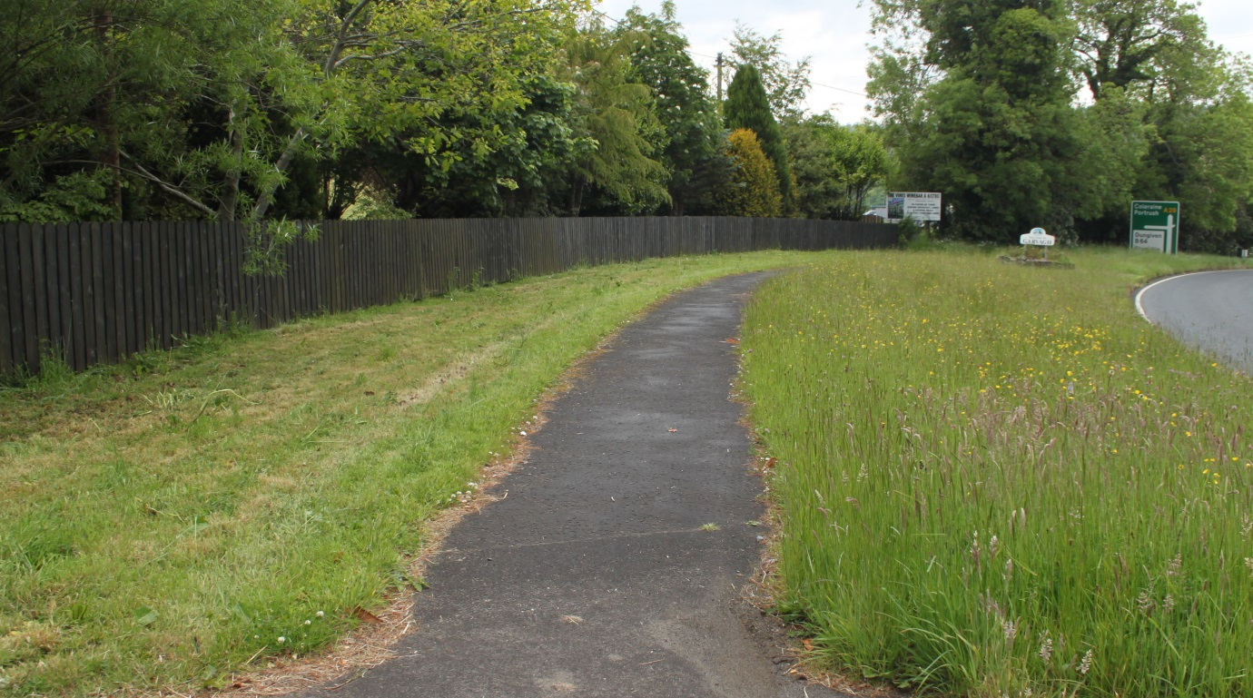

The grass on one side of the path has been mown and the other side has not been mown.

Which side do you prefer?
I like the grass that is mown short □. |  | I like the longer grass that is not mown □. | I have no preference □.

“Don’t Mow – Let It Grow” is a trial project within the Causeway Coast & Glens Borough Council area. It aims to protect and enhance the native plants and associated wildlife found on our amenity grassland and the grass verges along the sides of roads on selected sites. There are a variety of benefits to this project and we would like to know which are important to you.

WILDLIFE BENEFITS MOST IMPORTANT TO YOU
There are many wildlife benefits to the project. Some of these are listed below.
Can you tick those that are most important and least important to you please?
QUESTION 3 - WILDLIFE BENEFITS
Wildlife Benefits | Important to you | Not Important to you | Don’t know
Providing an area where a range of wild flowers can grow and seed.
Providing an area where wild flowers can provide food for wildlife.
Helping to save our endangered pollinators (bees, butterflies, hoverflies, moths).
Eradicating invasive alien plant species such as Japanese knotweed so our native plants can thrive.
Providing ‘corridors’ for wildlife to safely move from one area to another.
Increasing public understanding of our native plants and animals.

HUMAN WELL-BEING BENEFITS MOST IMPORTANT TO YOU
There are many Well-Being benefits to the project. These are listed below. Can you tick those that are most important and least important to you please?
QUESTION 4 – HUMAN WELL-BEING BENEFITS
Well-being Benefits. | Important to you | Not Important to you | Don’t know
Having attractive floral displays to appreciate.
Increasing public understanding of our native plants and animals.
Providing training to local volunteers about the native flowers and animals found in our grasslands.
Providing training kits for use when the project is finished on how to best manage our grasslands.

MONEY-SAVING BENEFITS MOST IMPORTANT TO YOU
There are many money-saving benefits to the project. These are listed below. Can you tick those that are important and not important to you please?
QUESTION 5 - MONEY SAVING BENEFITS
Money Saving Benefits | Important to you | Not Important to you | Don’t know
Reducing the number of times the grass is cut on our roadsides and amenity grassland.
Giving the grass, when it is cut, to local farmers for their livestock.
By protecting the health of our environment through supporting biodiversity and hence reducing the need for application of artificial chemicals etc.
Helping to eradicate invasive alien plant species such as Japanese knotweed that are impacting on buildings and infrastructure.
Helping to keep the costs down of the crops produced in Northern Ireland by supporting animals that pollinate these crops.
Please choose which set of benefits is the most important to you (you must only select one)
Wildlife benefits
Well-being benefits
Money saving benefits

Qu 6 | Please look carefully at the close-up pictures of the flowers and insects found in the longer grass:
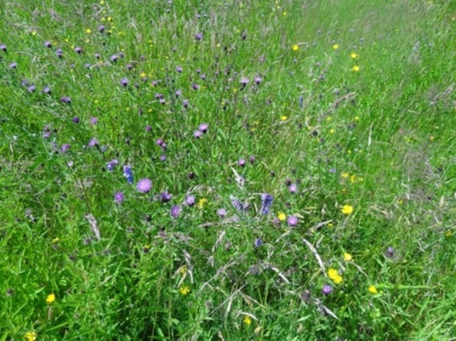 |  |  | 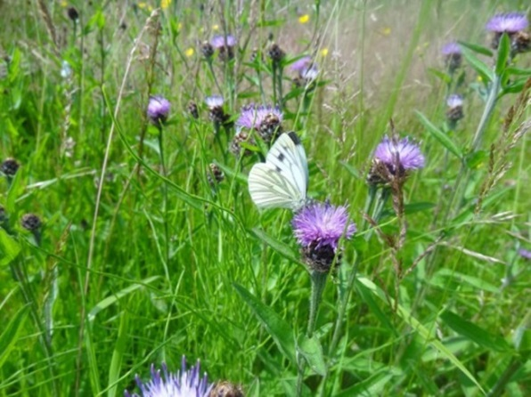
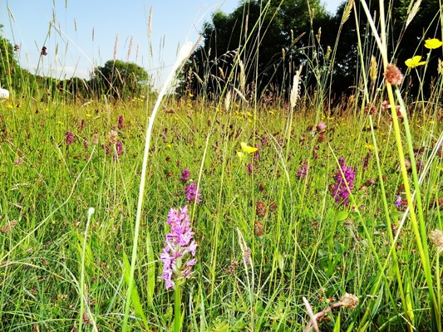 |  |  | 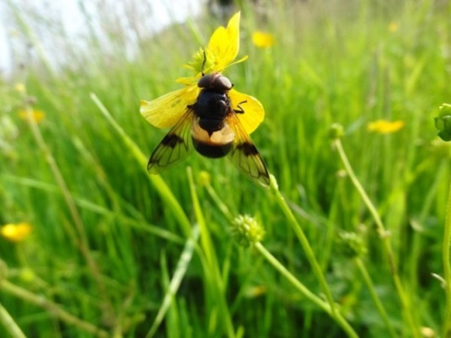
Now you can see the flowers and wildlife that grow and live in the longer grass, and you know of some of the benefits of the project. Has your opinion changed?
Yes □ No □. |  | I like the grass that is mown short □.  I like the longer grass that is not mown. □.  I have no preference □.

Do you live in the Causeway Coast & Glens Borough Council Area?
YES □ NO □

If NO are you a regular visitor to the Causeway Coast & Glens Borough Council Area?
YES □ NO □

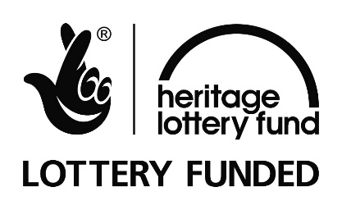
THANK YOU FOR COMPLETING THIS QUESTIONNAIRE
This project is a partnership between Causeway Coast and Glens Borough Council, Transport NI and Northern Ireland Environment Agency, and is supported by The National Lottery through the Heritage Lottery Fund and NIEA. Supported by
The National Lottery through the Heritage Lottery Fund.
If you would like to learn more about the project, please complete the following:
First Name |  | Last Name
Address
Postcode
E-Mail
Mobile:

 | How would you most like to find out more about this project? (tick all if relevant)
Newspapers □ | Radio □ | Internet □ | E-Mail □
Text Alert □ | Mobile Phone Call □ | Posters in Community Buildings □ | Social Media (eg. Facebook) □

Further Comments:

4 City Road, London EC1Y 2AA
+44 (0) 20 7580 5383
eftec@eftec.co.uk
eftec.co.uk
@eftecUK

A Biodiversity Strategy for Northern Ireland to 2020, by the Department of the Environment. See https://www.cbd.int/doc/world/gb/gb-nbsap-v3-p3-en.pdf
State of Nature 2016: Northern Ireland. See https://www.bto.org/sites/default/files/publications/state-of-nature-report-2016-northern-ireland.pdf
Ireland’s Environment: Nature & Biodiversity, by the Environmental Protection Agency. See https://www.heritageweek.ie/content/images/EPA_Factsheet_Biodiversity.pdf
Causeway Coast and Glens Borough Council: Local Biodiversity Action Plan. See https://www.causewaycoastandglens.gov.uk/uploads/general/Causeway_Coast__Glens_Council_BC_LBAP_27.02.13.pdf
An Invasive Alien Species Strategy for Northern Ireland, by the Department of the Environment. See https://invasivespeciesireland.com/wp-content/uploads/2017/10/invasive-species-2013-4-web.pdf
O’Sullivan et al., 2017. Optimising UK urban road verge contributions to biodiversity and ecosystem services with cost-effective management. Journal of Environmental Management, 191, 162-171.
Williams et al (2010) The Economic Cost of Invasive Non-Native Species on Great Britain. http://www.nonnativespecies.org/index.cfm?pageid=258
https://www.gov.uk/government/publications/valuing-environmental-impacts-guidelines-for-the-use-of-value-transfer
Sites of special scientific interests (SSSI) in the UK are equivalent to the Area of special scientific interest (ASSI) in Northern Ireland.
Christie and Rayment (2012) An Economic Assessment of the Ecosystem Service Benefits from SSSI Conservation Policy in England and Wales. Report to Defra.

