Verge and Open Space Grassland Survey
Management Guidelines
Site Name:  Finvoy Road B62 from Lislagan Road junction to Slievenaghy Road junction | Reference Number:  Verge 17 (both sides)
Grid References:  C954232 (N) to C961163 (S) | Survey details:  Four quadrats  C95674 22246  C95676 21214  C95513 20277  C95974 17364  Date first surveyed: 14/07/2016

Site description:
This site encompasses some significantly wide verges perfect for conservation management. The north end of the site was suffering from local cutting where the signs had been ignored. Some of the best stretches are where the roadside banks are at their steepest (70°). As with many wider verges the section most distant from the road remains uncut and here diversity is generally poor. There is a footpath allowing easy access on the eastern side. Most of the verge is hedged and backs on to farmland or private gardens. Litter and in some places rutting caused by vehicles are also issues. Overall the verge was assessed as average but has potential for improvement which is supported by the flora: some of the more interesting species included bird’s foot trefoil, milkwort, bush vetch, meadowsweet, lady’s mantle, self-heal, knapweed and tufted vetch. A number of negative species were often frequent such as bramble (close to the hedges), stinging nettle, creeping buttercup, soft rush, silverweed and coarse grasses.
Management Options:
- Mowing: The area should be mown and the material removed in August/September of each year. There must be continued dialogue with local residents to try and prevent unseasonal cutting. If dialogue fails then the locally cut stretches should be removed from the project.
- Remove litter. A litter pick should be organised by local volunteers prior to mowing.
- Survey: Undertake in July/early August – four quadrats.
- Review management options every 3 years
Site Map with approximate quadrat locations
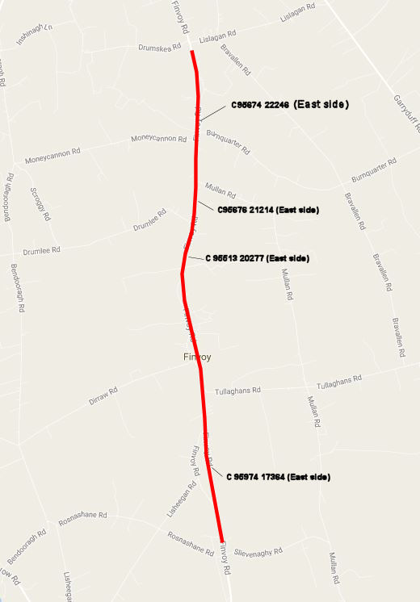
Image: July 2016
