Verge and Open Space Grassland Survey
Management Guidelines
Site Name:  Glenariff Road & Glen Road | Reference Number:  Verges – V8 & V9
Grid References:  Road co-ordinates:  V8 Glenariff Rd - D221216 (N) to D210206 (S)  V9 Glen Road - D221216 (N) to D219209 (S) | Survey details:  Total verge length:  1.4 km (V8) – N side of slope only  1.5km (V9) – both sides  Survey area: First 50 m from junction  Date first surveyed: 21.04.2016

Site description:
These two roads are taken together since they form a contiguous management area. The verge begins at the junction of the A43 with the Glen Road. V8 runs for 1.4km from here along the main A43 to the SW, ending at the townland boundary (Parkmore/Toberwine), while V9 runs south along Glen Road to the hairpin bend. Hazel woodland dominates the steep slopes along the road corridor and the display along the verges is particularly notable in spring when wild garlic, dog violets, primrose, St. John's wort, wild strawberry and lesser celandine are on show. Only the northern verge of V8 is included although a short stretch at the junction with V9 is very rich with early purple orchid and woodruff growing here (see management options below).

Management Options:
- Mow once a year in August / September. If an earlier or second cut is required (e.g. for road safety reasons) this should be done in February or early March before the flowering season.
- Remove cuttings if possible. Note - removal of cuttings may be impractical in some areas due to the steep nature of the verge.
- Survey in spring (April/early May) and summer (July).
- Include first 50m of southern side of V8. This area has a very rich flora.
- Review management options every 3 years
Verges V8 & V9 – Management Area
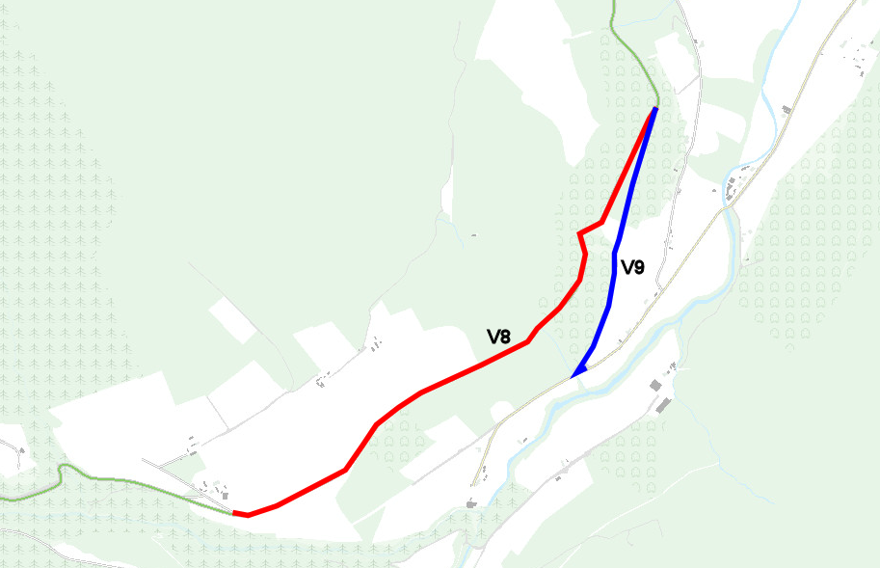
Survey area V8 (northern side)
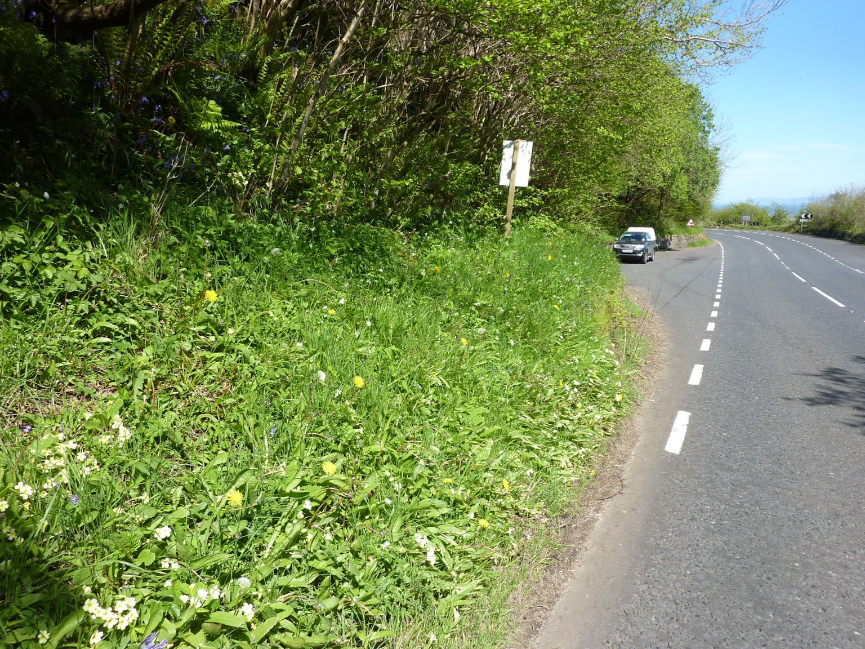
Southern side of V8
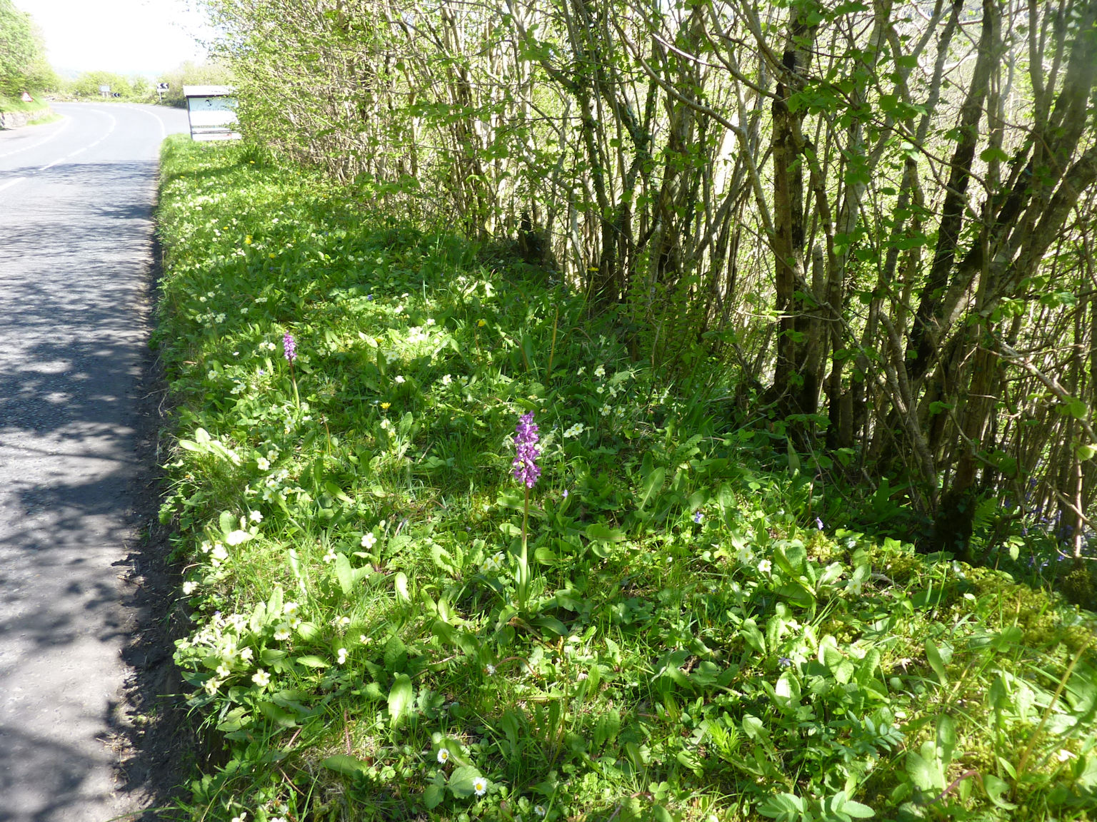
V9 survey area
