Verge and Open Space Grassland Survey
Management Guidelines
Site Name:  Shanreagh Park, Limavady | Reference Number:  Open Space CP4
Grid Reference:  C681 228 | Survey details:  Survey area: Whole site (0.19ha)  Date first surveyed: 08.08.2016

Site description:
This site consists of a small strip of amenity grassland at the north end of Shanreagh Park bounded by a tall hawthorn hedge to the north and a line of young planted trees to the south. A wide path had been mowed trough the strip. The grassland has been subjected to an intensive mowing regime and is rather species-poor. The presence of the grass marsh foxtail Alopecurus geniculatus suggests puddling or occasional flooding during heavy rain. There is potential for the management area to be extended to the south, so that the area would be doubled (see map below).
Management Options:
- Mow twice each year –in early spring (March) and again in late summer (September).
- Remove all cuttings. As the area is small these could potentially be raked and removed by volunteers.
- Avoid mowing a path through the strip. The strip is too small to warrant a mowed path through it. A mowed path would be justified if the management area is extended.
- Extend area under management (see map below). Mow a path through the managed area.
- Survey in June and again in August if possible – whole area
- Review management options every 3 years

Open space CP4 – management area
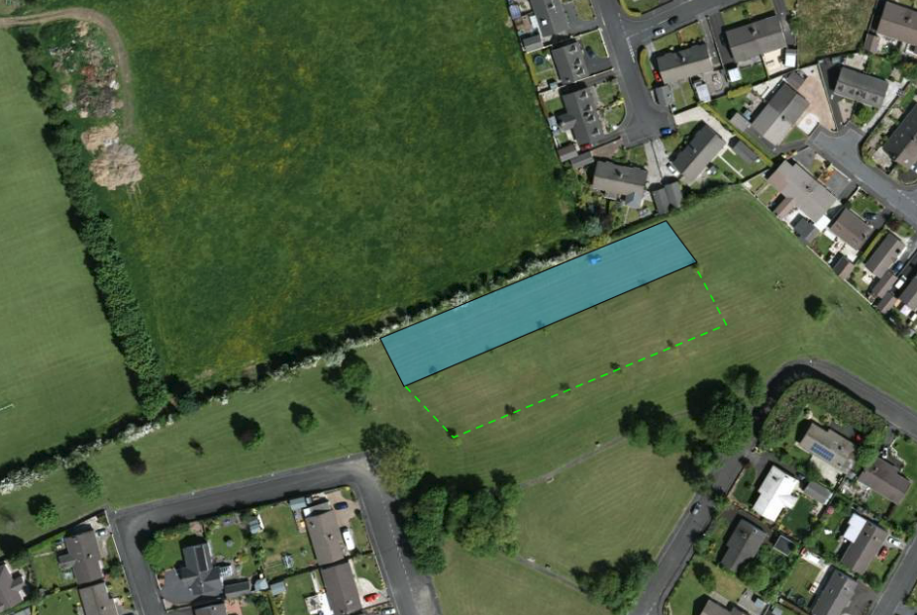
Suggested extension area – dotted line
CP4 on 8th August 2016
