Verge and Open Space Grassland Survey
Management Guidelines
Site Name:  Windyhill Road (B201) | Reference Number:  Verge - V24
Grid Reference:  Road co-ordinates: C797294 ( E ) to C720274 (W)  Knotweed quadrat – C78443 29945  Quadrat 1 – C75517 29078  Quadrat 2 – C73794 28501  Quadrat 3 – C75034 28965  Quadrat 4 – C75926 29146 | Survey details:  Total verge length: 10.2km (includes both sides of road)  Survey area: 5 x quadrats  Date first surveyed: 29.06.2016

Site description:
The Windyhill Road (or B201) is one of two main routes between the towns of Coleraine and Limavady which traverses an area of high ground. The project involves a 5.1 kilometre stretch of the upland section of the road with verges on both sides of the road being included. The road traverses an extensive area of heath, bog and commercial forestry and so the roadside verges are generally characterised by heathland vegetation.

At the highest part of the road, the verges are wide and stony with sparse vegetation at the roadside edge, but longer vegetation further from the road. These rank areas would benefit from the introduction of some mowing management. Scattered heathland species such as heath and common spotted orchids, heather and tormentil make the stony verges very interesting. The invertebrate fauna, including hoverflies and bees, is also diverse. Where longer vegetation occurs the most dominant species are grasses, greater bird’s-foot trefoil and in some wetter areas sedges and meadowsweet are common. Some of the verges are strewn with litter thrown from passing vehicles and this needs to be taken into account in managing the area. An additional quadrat was surveyed at the junction of the Isle Road to the east of the management area. This area has been identified by the Council as being affected by Japanese Knotweed and appropriate signage is in place.

Management Options:
- Mow once a year in September. If an earlier or second cut is required for road safety reasons this should be done in February or early March before the flowering season. The stony verges along the highest part of the road may not require to be cut, although this should be reviewed annually.
- Remove cuttings where possible. Removal of cuttings may be impractical here due to the length of the road, but some local initiatives may be possible along key stretches (e.g. around the quadrat points).
- Mow a wider strip where verges are >1m wide. The full width of the verge could be mowed, at least every other year if this is not possible annually.
- Remove litter. Plastic bottles and other litter are frequent along the verge. A litter pick should be organised prior to mowing.
- Survey in late June or July. More quadrats could be established so that there is up to one quadrat per kilometre of verge.
- Review management options every 3 years
- Continue to monitor and control the Japanese Knotweed (Quadrat 1). The knotweed has not yet spread onto the verge at the road junction and so a certain area can be cut to maintain sightlines. However the knotweed growing behind the fence should be controlled appropriately and its distribution monitored.
Verge 24 Management area and location of quadrats
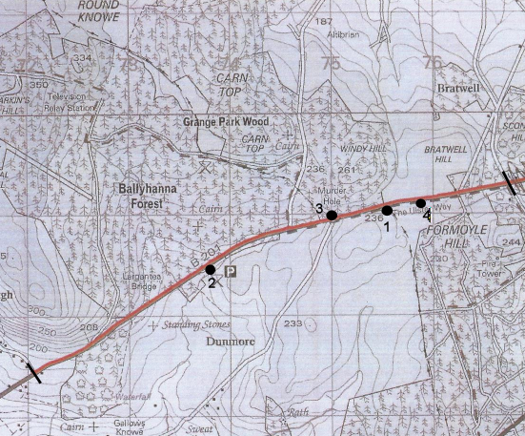
Knotweed quadrat
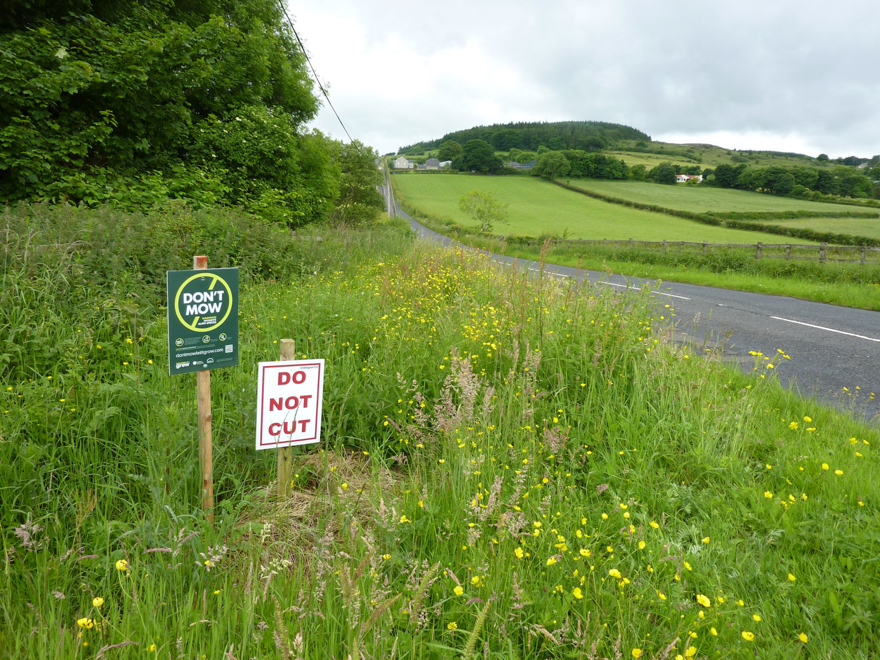
Quadrat 1
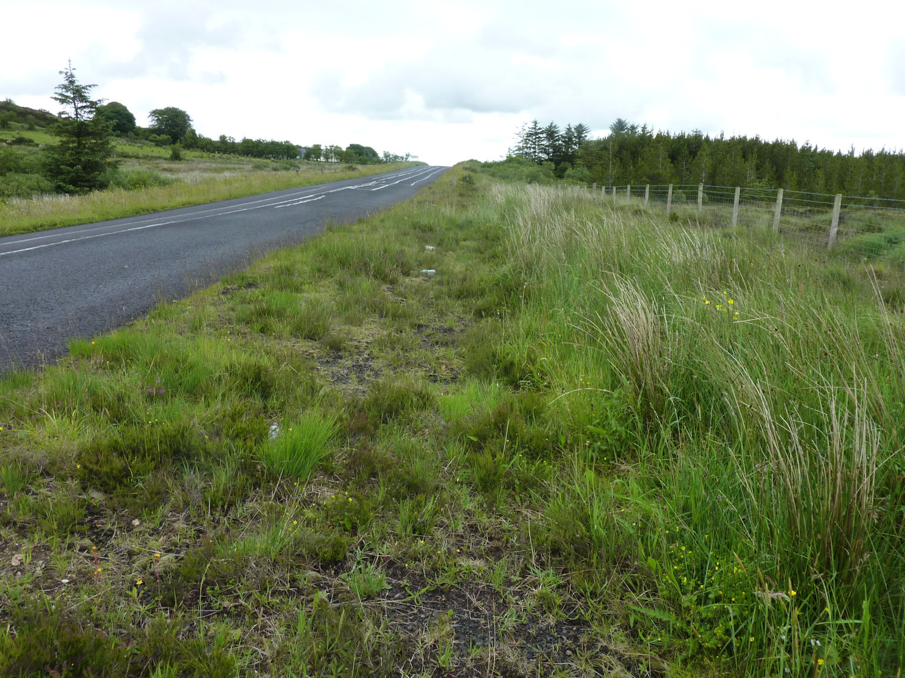
Quadrat 2
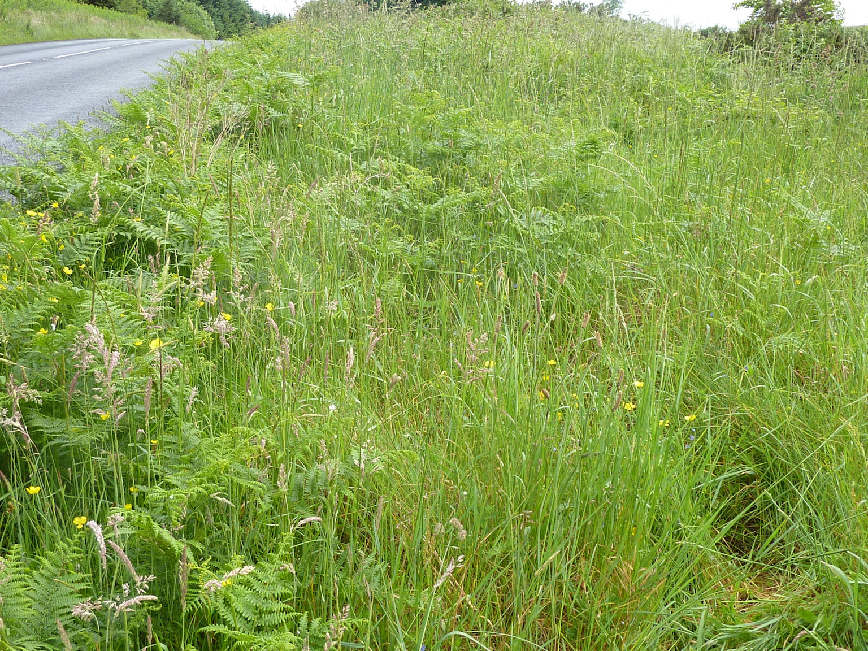
Quadrat 3
